**LAB #05:**

**Name: Mohkum din__________________ Reg #: F2025-1028___________________**

# LAB #05 – Conditional Statements and Decision Making in C++

## Task 1: Time Calculator

**CLO1**  
**CLO2**

**Objective:**  
To convert seconds into minutes, hours, and days using conditional statements.

**Problem Statement:**  
Write a program that asks the user to enter a number of seconds.

* If the number of seconds is greater than or equal to 60, display the number of minutes.
* If it is greater than or equal to 3,600, display the number of hours.
* If it is greater than or equal to 86,400, display the number of days.
* Otherwise show seconds.

**Solution:**

|  |
| --- |
| #include <iostream>  using namespace std;  int main() {  double seconds;  cout << "Enter the number of seconds: ";  cin >> seconds;  if (seconds >= 86400) {  double days = seconds / 86400;  cout << "That is approximately " << days << " days." << endl;  }  else if (seconds >= 3600) {  double hours = seconds / 3600;  cout << "That is approximately " << hours << " hours." << endl;  }  else if (seconds >= 60) {  double minutes = seconds / 60;  cout << "That is approximately " << minutes << " minutes." << endl;  }  else {  cout << "That is " << seconds << " seconds." << endl;  }  return 0;  }Code here |

**Sample Output:**

Enter number of seconds: 7200

Hours: 2

## Task 2: Color Mixer (nested loop)

**CLO1**  
**CLO2**

**Objective:**  
To determine the resulting color when two primary colors are mixed.

**Problem Statement:**  
The colors red, blue, and yellow are known as primary colors because they cannot be  
made by mixing other colors. When you mix two primary colors, you get a secondary  
color, as shown here:

* When you mix red and blue, you get purple.
* When you mix red and yellow, you get orange.
* When you mix blue and yellow, you get green.

Write a program that prompts the user to enter the names of two primary colors to  
mix. If the user enters anything other than “red,” “blue,” or “yellow,” the program  
should display an error message. Otherwise, the program should display the name of  
the secondary color that results by mixing two primary colors.

**Solution:**

|  |
| --- |
| Code here |

**Sample Output:**

Enter first primary color: red

Enter second primary color: blue

Resulting color: Purple

## Task 3: Middle of Three Numbers (if else if)

**CLO1**  
**CLO2**

**Objective:**  
To find the middle number among three user inputs.

**Problem Statement:**  
Write a program that lets the user input three numbers and outputs the number whose  
value is between the other two. This sounds like a very easy program, but it is not as  
straightforward as it sounds. This is a typical example of a task that is trivial for a  
human, but one that many people find hard to express in a program. Test at least for  
the values 1, 2, and 3 and for the values 3, 2, and 1.

**Solution:**

|  |
| --- |
| Code here |

**Sample Output:**

Enter three numbers: 3 1 2

Middle number: 2

## Task 4: Days in a Month (both if else if and nested if)

**CLO1**  
**CLO2**

**Objective:**  
To display the number of days in a given month and year, accounting for leap years.

**Problem Statement:**  
Write a program that asks the user to enter the month (letting the user enter an integer  
in the range of 1 through 12) and the year. The program should then display the number of days in that month. Use the following criteria to identify leap years:

1. Determine whether the year is divisible by 100. If it is, then it is a leap year if and  
   only if it is divisible by 400. For example, 2000 is a leap year but 2100 is not.
2. If the year is not divisible by 100, then it is a leap year if and only if it is divisible by  
   4. For example, 2008 is a leap year but 2009 is not.

Here is a sample run of the program:  
Enter a month (1–12): **2 Enter**Enter a year: **2008 Enter**29 days

**Solution:**

|  |
| --- |
| Code here |

**Sample Output:**

Enter month (1-12): 2

Enter year: 2008

Number of days: 29

## Task 5: Math Tutor

**CLO1**  
**CLO2**

**Objective:**  
To simulate a math quiz that checks a student's addition answer.

**Problem Statement:**



Write a program that can be used as a math tutor for a young student. The program should display two random numbers that are to be added, such as:  
 247  
+129



The program should wait for the student to enter the answer. If the answer is correct,  
a message of congratulations should be printed. If the answer is incorrect, a message  
should be printed showing **Solution:**

|  |
| --- |
| Code here  #include <iostream>  #include <cstdlib>  #include <ctime>  using namespace std;  int main() {  srand(time(0));  int num1 = rand() % 500;  int num2 = rand() % 500; |

**Sample Output:**

Add the following numbers:

247 + 129 = 376

Congratulations! Correct Answer.

## Task 6: Software Sales

**CLO1**  
**CLO2**

**Objective:**  
To calculate total purchase cost based on quantity discounts.

**Problem Statement:**  
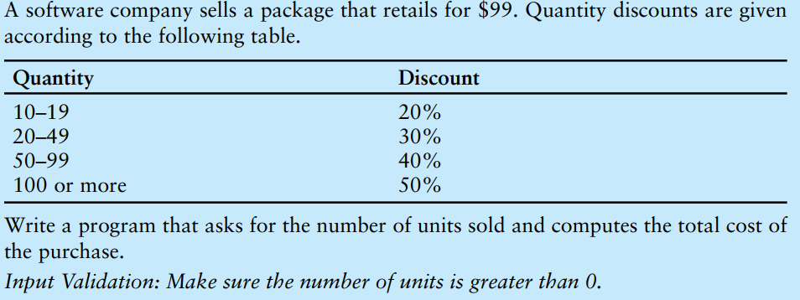**Solution:**

|  |
| --- |
| Code here |

**Sample Output:**

Enter number of units sold: 25

Total cost after discount: $1732.5

## Task 7: Book Club Points

**CLO1**  
**CLO2**

**Objective:**  
To award points based on the number of books purchased.

**Problem Statement:**

**Solution:**

|  |
| --- |
| Code here |

**Sample Output:**

Enter number of books purchased: 3

Points awarded: 30

## Task 8: Membership Fees

**CLO1**  
**CLO2**

**Objective:**  
To calculate the membership fee based on age and activities attended.

**Problem Statement:**



**Solution:**

|  |
| --- |
| Code here |

**Sample Output:**

Enter your age: 10

Enter number of activities attended: 3

Membership fee: $6.25

## Task 9: Shipping Charges

**CLO1**  
**CLO2**

**Objective:**  
To compute shipping cost based on weight and distance.

**Problem Statement:**

**Solution:**

|  |
| --- |
| Code here |

**Sample Output:**

Enter weight of package (kg): 5

Enter distance (miles): 1000

Shipping cost: $4.4

## Task 10: Fat Gram Calculator

**CLO1**  
**CLO2**

**Objective:**  
To calculate and evaluate fat percentage in food.

**Problem Statement:**  
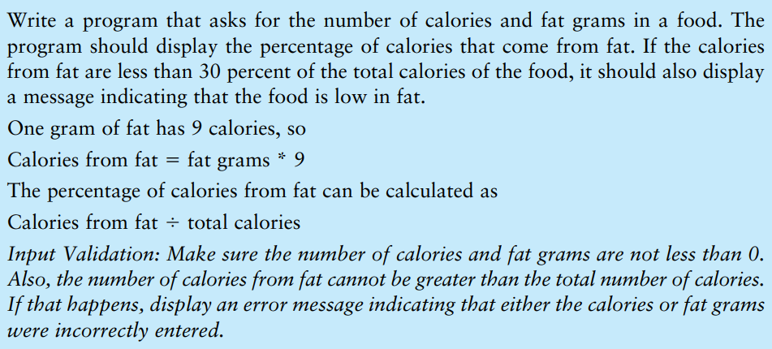

**Solution:**

|  |
| --- |
| Code here |

**Sample Output:**

Enter total calories: 500

Enter fat grams: 10

Calories from fat: 90

Percentage of calories from fat: 18%

This food is low in fat.

end